

User Acceptance Test

for

Product Item Module

Myanmar Software Engineer Contest 2020

Team Name: Charmers Tech

Date: 9/11/2020

Version: Final Version

Content

1. Purpose of the Document

2. Project URL

3. Test Cases

3.1 Test Cases of Main Dashboard

3.2 Test Cases of “Add Product” page

3.3 Test Cases of “Edit Product” page

4. Document Signature

5. Screenshots of “Product Item Module”

6. References

**1. Purpose of the document**

This document explains the various activities of user acceptance test that performed as part of the testing of the “Product Item” module.

2. **Project URL**

Since you have finished deployment steps, you can also test this application via following link on your browser.

You can view the main dashboard of “Product Item Module”.

**localhost/SE2020/App/index.php**

To test the “Product Item Module”, please enter the following link:

[**https://itemmodule.herokuapp.com/SE2020/App/**](https://itemmodule.herokuapp.com/SE2020/App/)

**3. Test Cases**

**3.1 Test Cases of Main Dashboard**

|  |  |  |  |
| --- | --- | --- | --- |
| **No** | **Test Procedure** | **Expected Result** | **Pass/Fail** |
| 1 | Click “Add New Product” Button | Appear “Add Product” Page | Pass |
| Click “Submit” button without data | Appear “Please Fill This Field” alert box | Pass |
| Click “Cancel” button | Appear “Main Dashboard” | Pass |
| 2 | Search by “Product name” | Appear related product information | Pass |
| Search by not existing “Product name” | Appear “Product Not Found” | Pass |
| 3 | Click “View” Icon | Appear “View Detail” Page | Pass |
| Click “Back” Button | Appear “Main Dashboard” | Pass |
| 4 | Click “Edit” Icon | Appear “Edit Product” Page | Pass |
| Click “Save” button without data | Appear “Please Fill This Field” alert box | Pass |
| Click “Cancel” button | Appear “Main Dashboard” | Pass |
| 5. | Click “Delete” Icon | Appear “Delete Product” Page | Pass |
|  | Click “Yes” Button | Delete product record and appear “Main Dashboard” | Pass |
| Click “No” Button | Appear “Main Dashboard” | Pass |

**3.2 Test Cases of “Add Product” page**

|  |  |  |  |
| --- | --- | --- | --- |
| **No** | **Tasks** | **Test Data** | **Pass/Fail** |
| 1. | Product Name field | Accept both Varchar and integer  (e.g. Iphone, Iphone12 pro…) | Pass |
| Accept Varchar  (e.g. Iphone, …) | Pass |
| Not accept blank field | Pass |
| 2. | Product Photo | File type must be .jpeg, .png, .jpg  (e.g. Dell Pro.jpg…) | Pass |
| Not accept blank field | Pass |
| 3. | Description Field | Accept both Varchar and integer  (e.g. **Lorem Ipsum** is simply dummy text of the printing and typesetting industry...) | Pass |
| Not accept blank field | Pass |
| 4. | Stock Balance Field | Accept integer from “0” to “99999”. | Pass |
| Not accept blank field | Pass |
| 5. | Price Field | Accept integer greater than zero | Pass |
| Not accept blank field | Pass |
| 6. | Warehouse | Choose one | Pass |

**3.3 Test Cases of “Edit Product” page**

|  |  |  |  |
| --- | --- | --- | --- |
| **No** | **Task** | **Test Data** | **Pass/Fail** |
| 1. | Product Name field | Update product name  (e.g. Iphone, Iphone12 pro…) | Pass |
| Not accept blank field | Pass |
| 2. | Product Photo | File type must be .jpeg, .png, .jpg  (e.g. Dell Pro.jpg…) | Pass |
| Not accept blank field | Pass |
| 3. | Description Field | Update product information  (e.g. **Lorem Ipsum** is simply dummy text of the printing and typesetting industry...) | Pass |
| Not accept blank field | Pass |
| 4. | Stock Balance Field | Update stock balance from “0” to “99999”. | Pass |
| Not accept blank field | Pass |
| 5. | Price Field | Update price greater than zero | Pass |
| Not accept blank field | Pass |
| 6. | Warehouse | Choose one | Pass |

**4. Document Signature**

|  |  |  |  |
| --- | --- | --- | --- |
| **Role** | **Name** | **Signature** | **Date** |
| **Service Owner** |  |  |  |
| **Tester** |  |  |  |
| **Add new row if needed…** |  |  |  |

**5. Screenshots of “Product Item Module”**

**5.1 Main Dashboard**

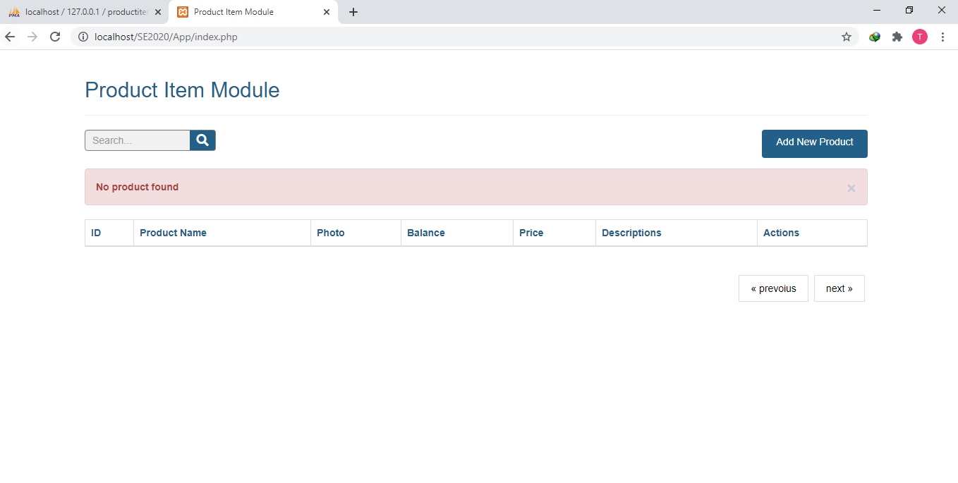

**5.2 Add New Product Page**

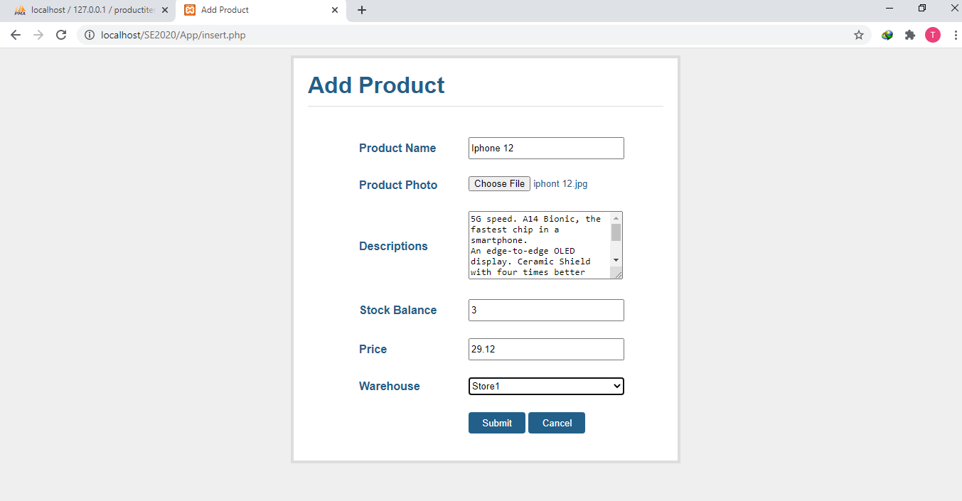

**5.3 Search Product Page**

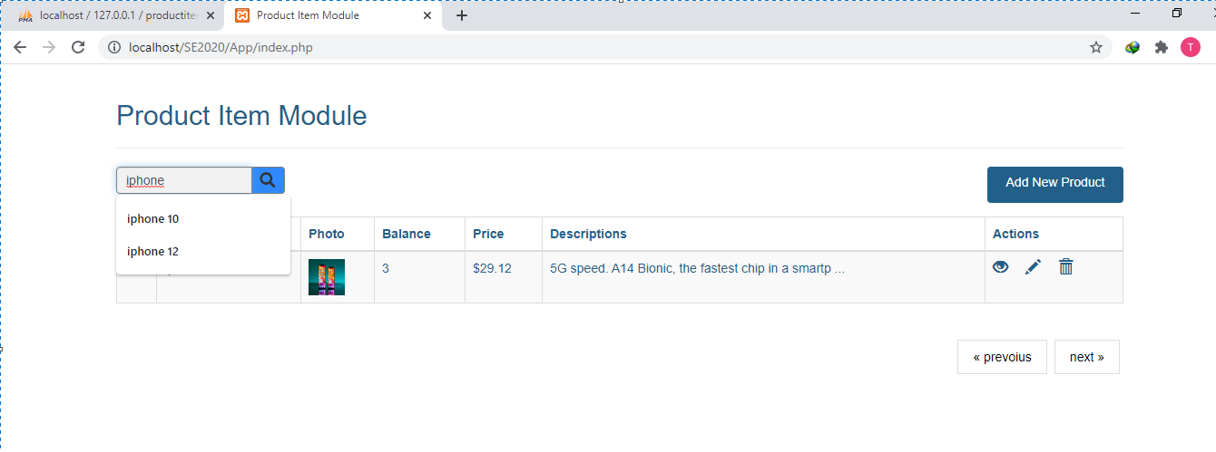

**5.4 View Detail Page**

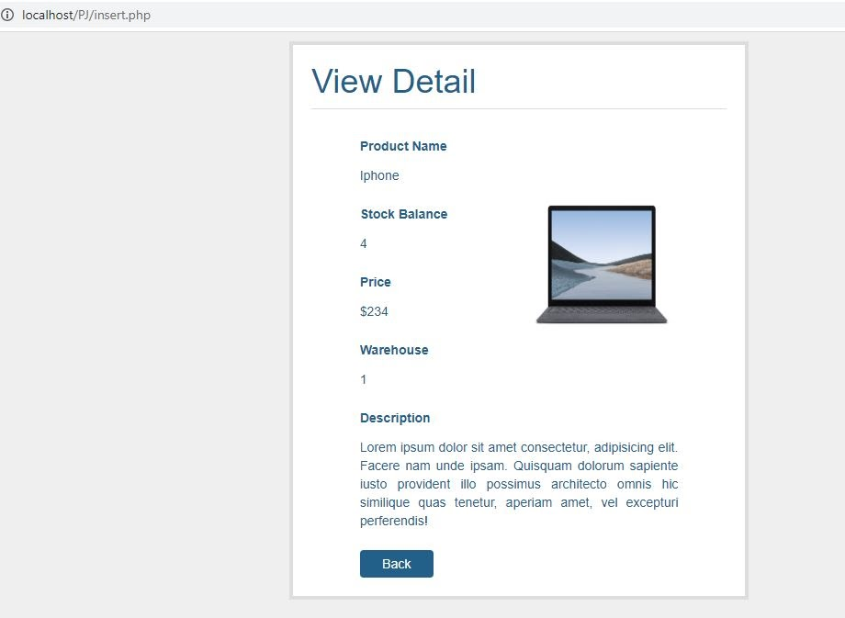

**5.5 Edit Product Page**

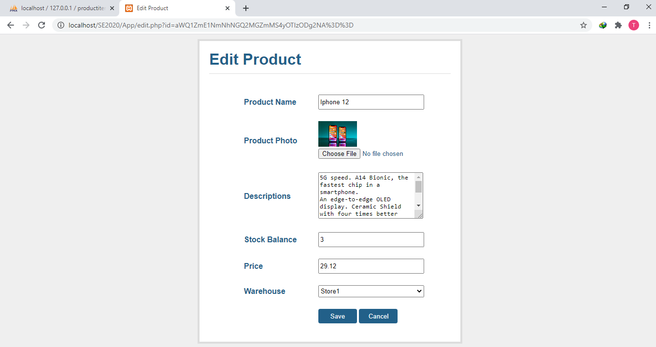

**5.5 Delete Page**

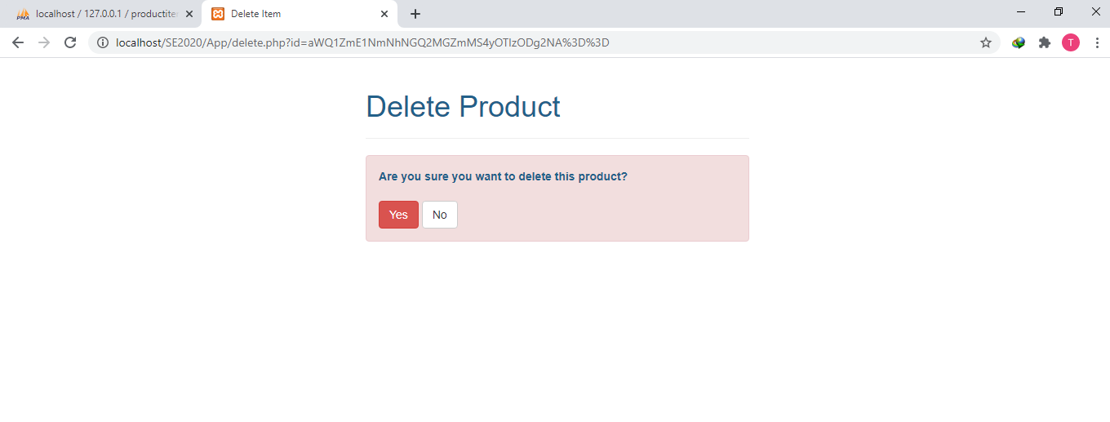

**6. References**

* <https://www.coleyconsulting.co.uk/UAT_Test_Plan.htm>
* <https://www.guru99.com/user-acceptance-testing.html>